**Dropping the Ball**

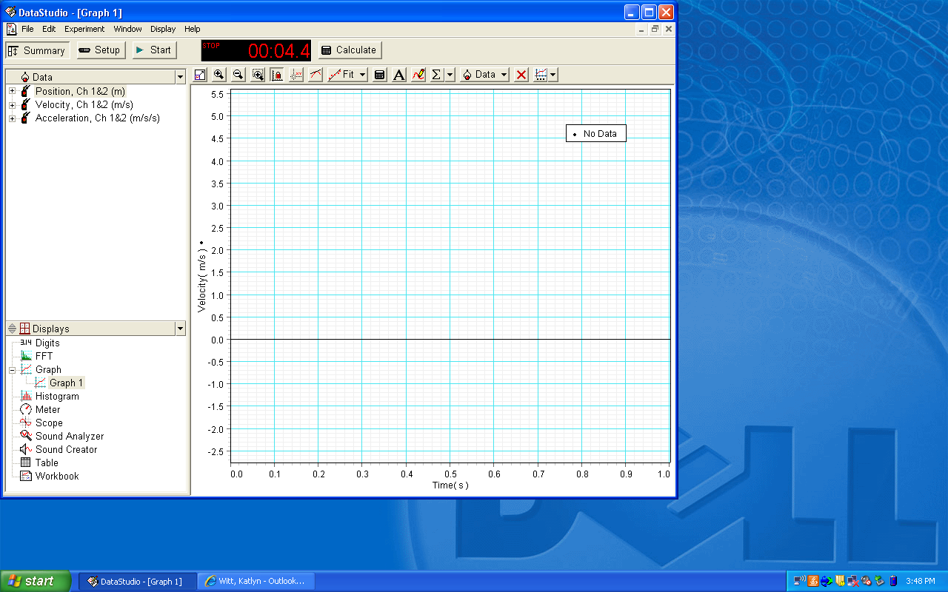

Once you have your motion sensor set up with the Science Workshop 500 interface and you have connected it to the computer, click and drag “Graph” (under Displays) up to “Velocity”, like in Figure 1, so you can create a velocity vs. time graph.

When you get a set of data, it might look something like Figure 2. You want to analyze only the initial, falling motion, so you want to look at that time interval only. You can zoom in by clicking on the numbers along the Time axis and dragging them to the right.

Once you have zoomed in on the time interval, click in the graph and drag to make a box to select the portion of your graph that is primarily linear. It should look like Figure 3. Sketch this portion of the graph in your lab.

Figure 1

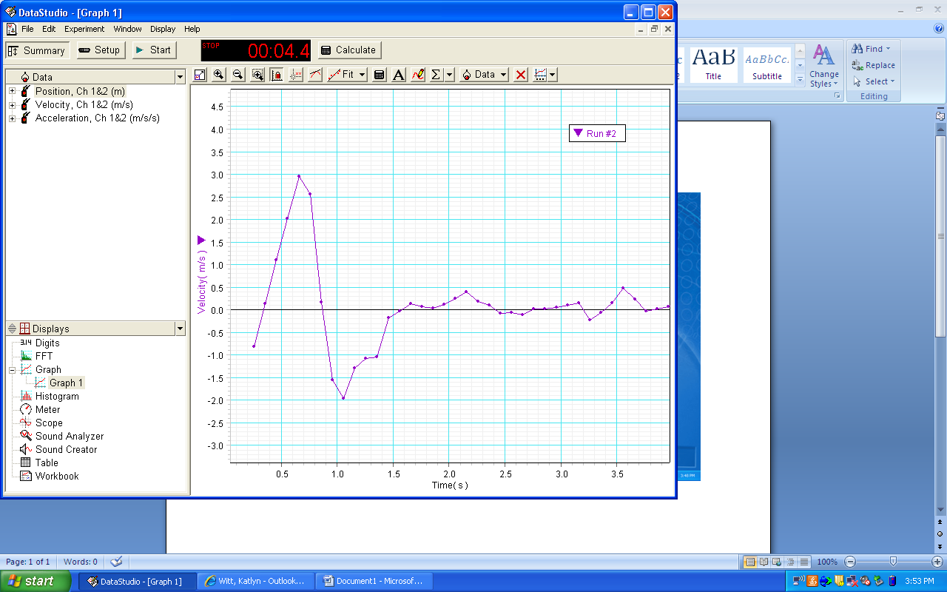

Figure 2

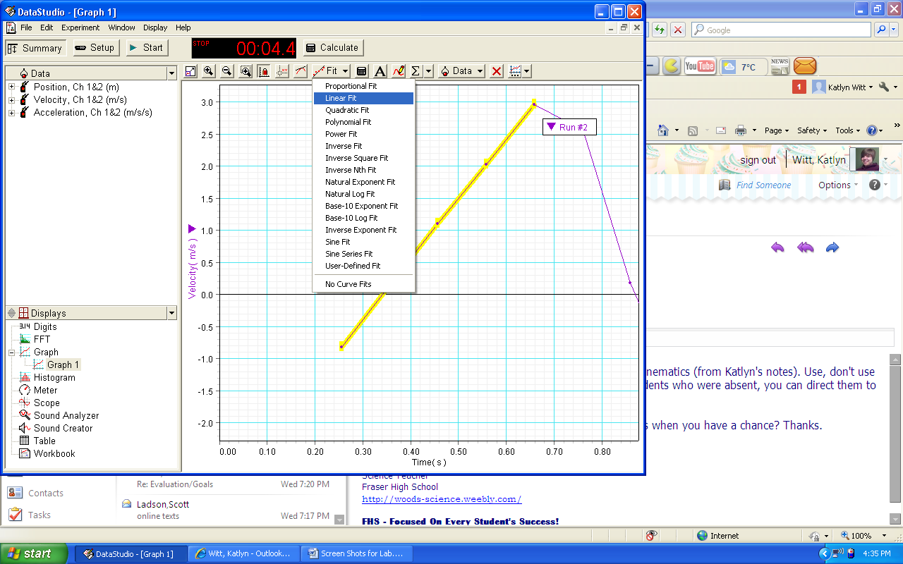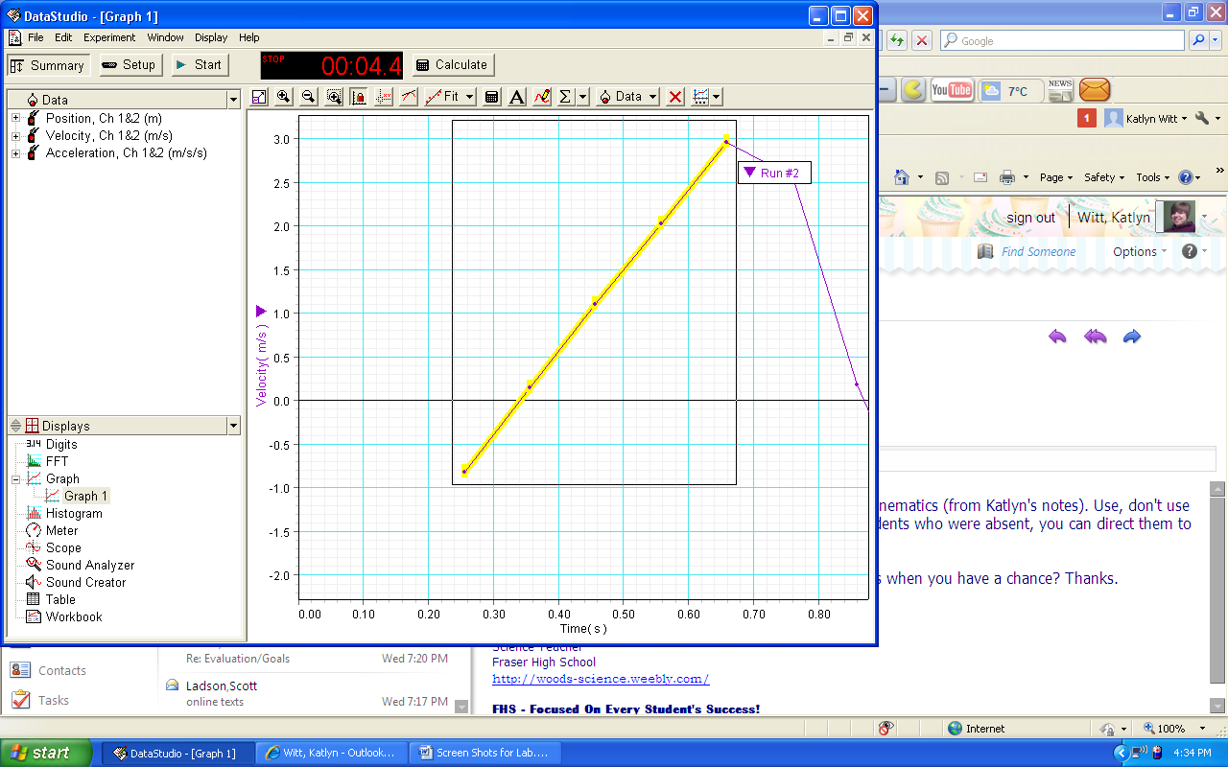

Figure 3

Once you have that portion of the graph selected, click on “Fit” at the top, and choose Linear Fit, like in Figure 4.

A box should show up giving you m (slope) and b (Y intercept). Record the equation of the line   
(y = mx + b) in your lab.

As you run additional trials, they will all show up on the same graph. To select the data that appears on the graph, click the “Data” button and check/uncheck the appropriate data runs, as seen in Figure 6.

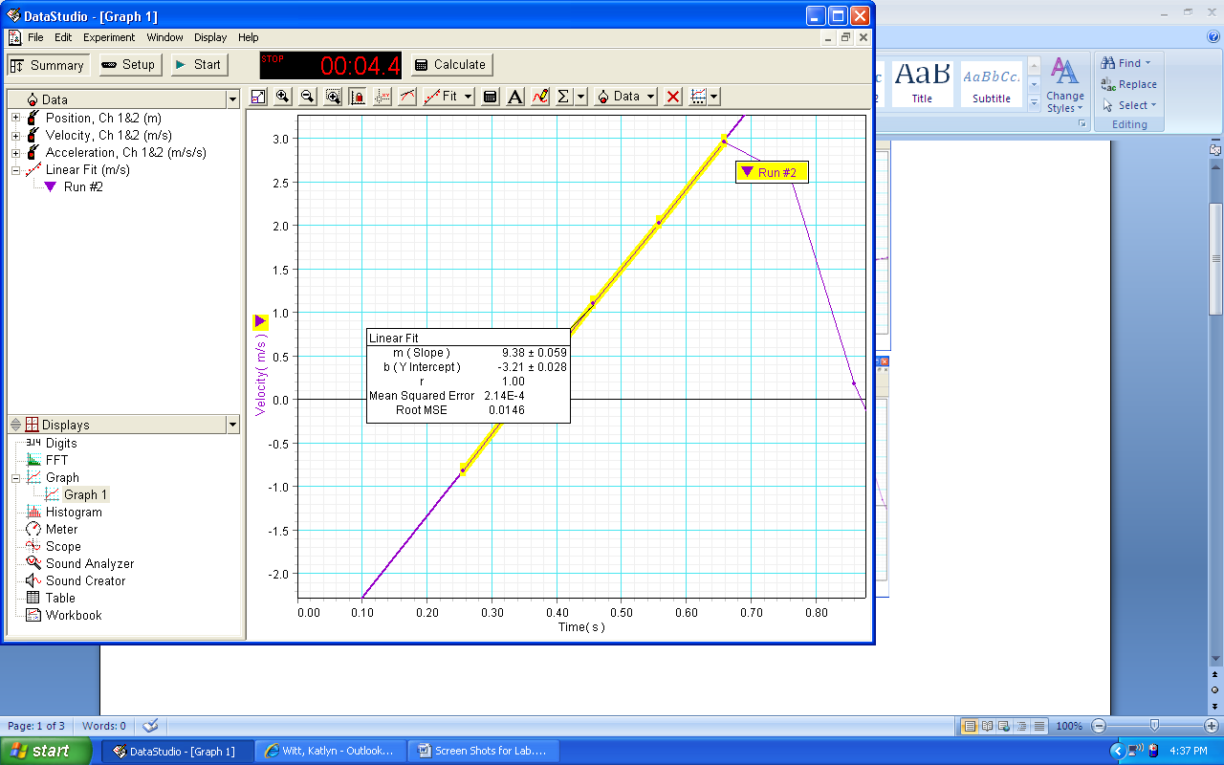

Figure 4

Figure 5

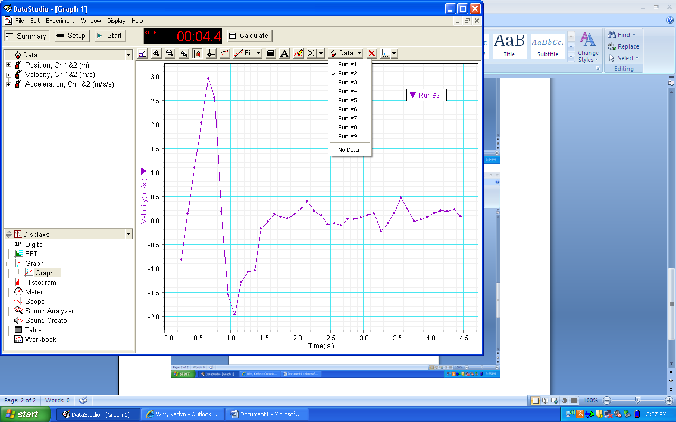

Figure 6